SESSION 3 - WHERE Clause & Operators Topics: WHERE=, <>, >, <, <=, >=Logical operators AND, OR, NOT Demo: Filter employees with salary > 50000 and in "IT" dept.

Answer:

What is the WHERE Clause?
- The WHERE clause is used to filter rows based on a condition.
- Syntax
SELECT column1, column2
FROM table_name
WHERE condition;
- Example:
SELECT *
FROM employees
WHERE salary > 50000;

Comparison Operators
- Equal to “=”
  - Find employees who work in the IT department.
SELECT *
FROM employees
WHERE department = 'IT';
- Not Equal “<>”
  - Find employees who are not in the IT department.
SELECT *
FROM employees
WHERE department <> 'IT';
- Greater Than “>”
  - Find employees whose salary is greater than ₹50,000.
SELECT *
FROM employees
WHERE salary > 50000;

- Less Than “<”
  - Find employees whose salary is less than ₹50,000.
SELECT *
FROM employees
WHERE salary < 50000;
- Greater Than or Equal “>=”
  - Find employees whose salary is ₹50,000 or more.
SELECT *
FROM employees
WHERE salary >= 50000;
- Less Than or Equal “<=”
  - Find employees whose salary is ₹50,000 or less.
SELECT *
FROM employees
WHERE salary <= 50000;
- Logical Operator “AND”
  - AND is used when both conditions must be TRUE.
  - Example
    - Find employees whose salary is greater than ₹50,000 AND who work in IT.
SELECT *
FROM employees
WHERE salary > 50000
AND department = 'IT';
- Logical Operator “OR”
  - OR is used when at least one condition must be TRUE.
  - Find employees who are either in IT OR HR.
SELECT *
FROM employees
WHERE department = 'IT'
OR department = 'HR';
- Logical Operator “NOT”
  - NOT reverses a condition.
  - Find employees who are not in the IT department.
SELECT *
FROM employees
WHERE NOT department = 'IT';

Demo
CREATE DATABASE employees_data
CREATE TABLE employees (
employee_id INT PRIMARY KEY,
employee_name VARCHAR(50),
department VARCHAR(30),
salary INT,
city VARCHAR(30)
);
INSERT INTO employees
(employee_name, department, salary, city)
VALUES
('Pooja', 'HR', 65000, 'Mumbai'),
('Karan', 'Finance', 65000, 'Surat'),
('Sneha', 'IT', 90000, 'Ahmedabad'),
('Vishal', 'Sales', 52000, 'Rajkot'),
('Meera', 'Sales', 55000, 'Vadodara');
SELECT * FROM `employees`
WHERE salary>50000
AND department="IT"

Output
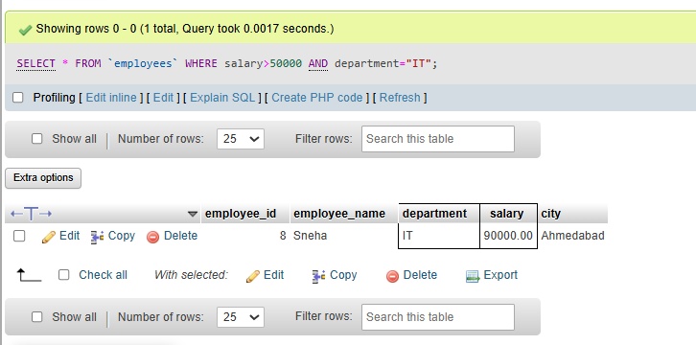

Tasks_01
CREATE DATABASE food_delivery_db
CREATE TABLE restaurant_data(
restaurant_id int PRIMARY KEY AUTO_INCREMENT,
restaurant_name varchar(50) NOT NULL,
city varchar(50) NOT NULL,
cuisine_type varchar(50) NOT NULL,
rating float,
opening_time time NOT NULL,
closing_time time NOT NULL
)
INSERT INTO restaurant_data
(restaurant_name, city, cuisine_type, rating, opening_time, closing_time)
VALUES
('Spice Garden', 'Ahmedabad', 'Indian', 4.5, '10:00:00', '23:00:00'),
('Pizza Hub', 'Surat', 'Italian', 4.2, '11:00:00', '22:30:00'),
('Dosa Corner', 'Vadodara', 'South Indian', 4.6, '08:00:00', '22:00:00'),
('Burger House', 'Rajkot', 'Fast Food', 4.1, '11:00:00', '23:30:00'),
('The Food Factory', 'Ahmedabad', 'Multi-Cuisine', 4.4, '10:30:00', '23:00:00')
SELECT * FROM restaurant_data
WHERE rating>=4.5

Output
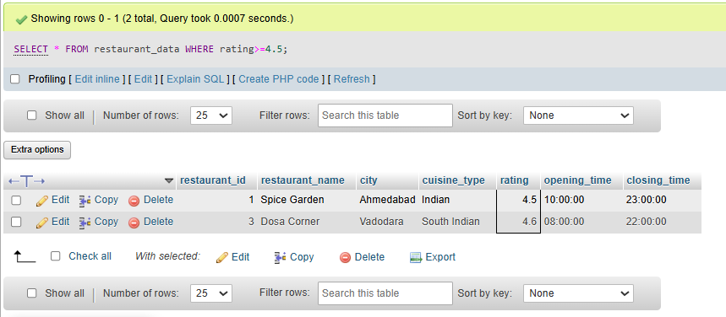

Tasks_02
CREATE DATABASE movies_details
CREATE TABLE movies (
movie_id INT PRIMARY KEY AUTO_INCREMENT,
movie_name VARCHAR(100),
release_year INT,
genre VARCHAR(50),
rating DECIMAL(3,1)
);
INSERT INTO movies
(movie_name, release_year, genre)
VALUES
('Jawan', 2023, 'Action'),
('Dangal', 2016, 'Drama'),
('KGF Chapter 2', 2022, 'Action'),
('3 Idiots', 2009, 'Comedy');
SELECT * FROM `movies`
WHERE release_year>2020
AND genre="Action"

Output
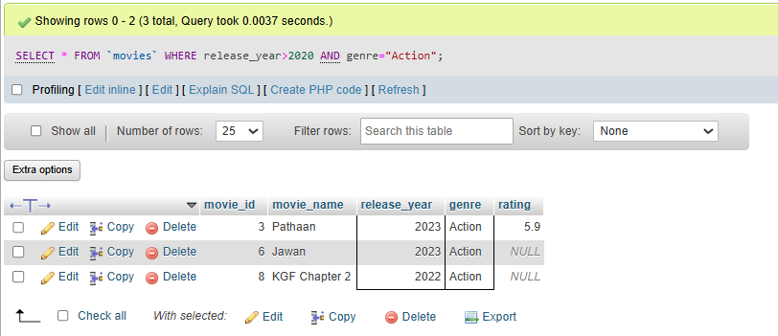

Task_03
CREATE DATABASE analytics_db
CREATE TABLE products (
product_id INT PRIMARY KEY AUTO_INCREMENT,
product_name VARCHAR(100),
price DECIMAL(10,2),
category VARCHAR(50)
);
INSERT INTO products
(product_name, price, category)
VALUES
('Laptop', 55000, 'Electronics'),
('Mouse', 400, 'Electronics'),
('Keyboard', 800, 'Electronics'),
('Office Chair', 4500, 'Furniture'),
('Notebook', 250, 'Stationery');
SELECT * FROM `products`
WHERE category<>"Electronics"
AND price<500

Output
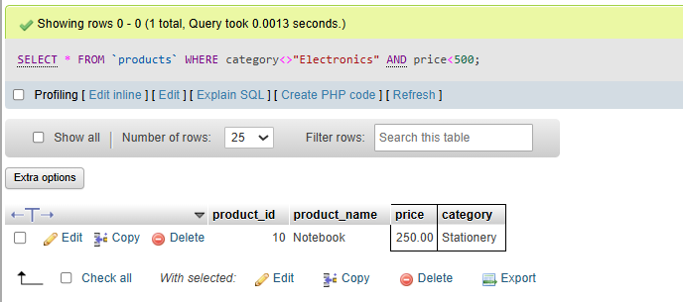

Tasks_04
CREATE DATABASE music_streaming_db
CREATE TABLE users (
id INT PRIMARY KEY,
name VARCHAR(50),
city VARCHAR(50),
followers INT
);
INSERT INTO users
(id, name, city, followers)
VALUES
(1, 'Rahul', 'Ahmedabad', 1500),
(2, 'Priya', 'Surat', 1200),
(3, 'Amit', 'Rajkot', 800),
(4, 'Neha', 'Vadodara', 2500),
(5, 'Karan', 'Ahmedabad', 3000);
SELECT * FROM users
WHERE NOT city = "Ahmedabad"
AND followers>1000

Output
